TC-CMS-022
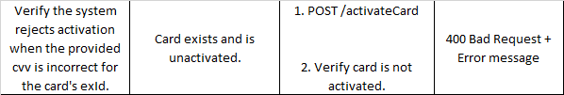
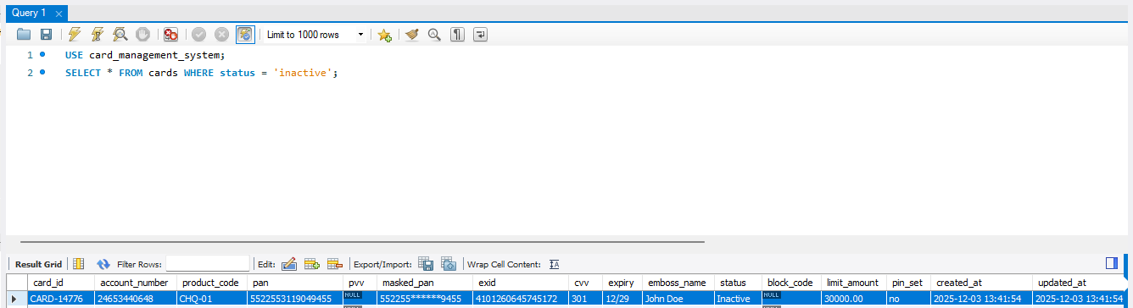
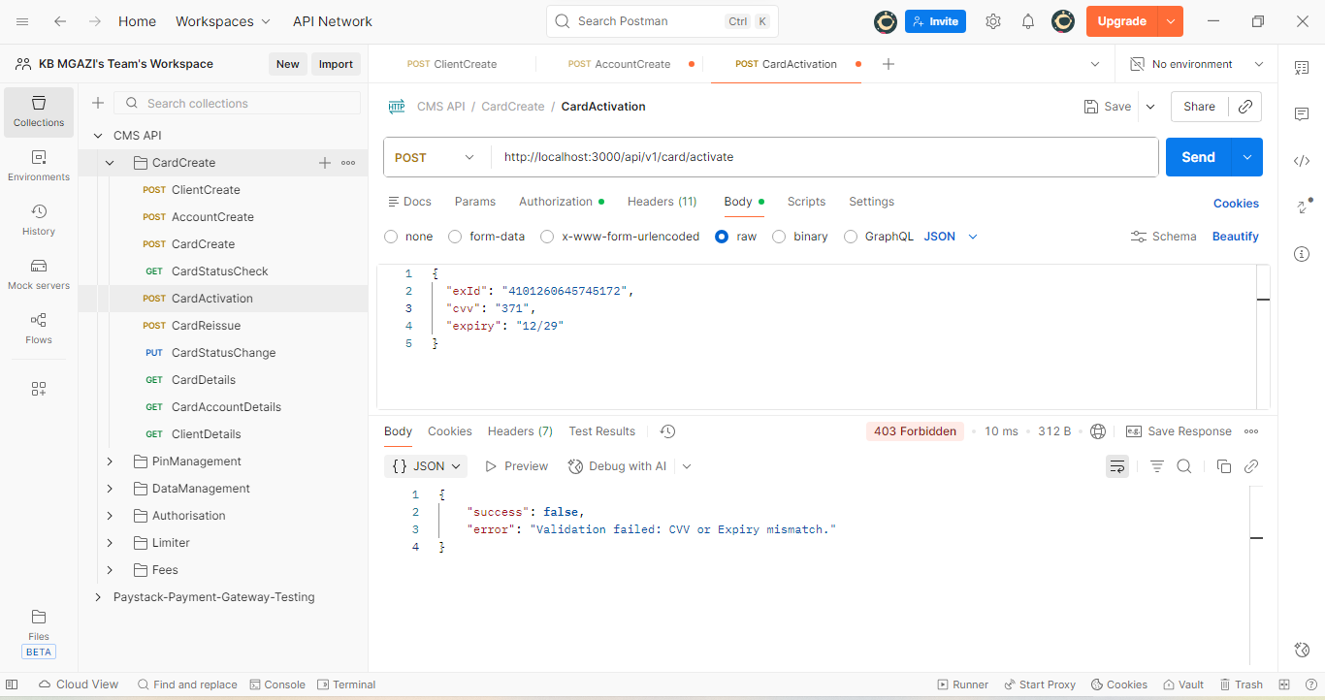
Request:
{
"exId": "4101260645745172",
"cvv": "371",
"expiry": "12/29"
}

Response:
{
"success": false,
"error": "Validation failed: CVV or Expiry mismatch."
}

